Our Redeemer Lutheran Church Prospect Heights, IL
Twelfth Sunday after Pentecost August 28, 2022

IMPERATIVE FOR CHRISTIAN LIVING

AS WE GATHER
Christians do good works most of the time without even thinking about it. That’s because faith is an active, living, real thing. God’s Word for this day is all about how God-given faith shows itself in a Christian’s life—in one’s attitude, relationships, words, and deeds. Those without faith, like many of the Pharisees in today’s Gospel, consider “good works” only as a way to influence or manipulate other people and even God. Such good works are never really good at all but are tainted with sin, selfishness, and pride. True faith, on the other hand, is not even our work alone at all, but the work of God the Holy Spirit who, through the Word of God and His Holy Sacraments, instills and inspires in the Christian the mind of Christ, the faithfulness and righteousness of Jesus. Such faith also endures the cross and all sufferings related to living in the world still disfigured by deadly sin. In faith God equips you with “everything good that you may do His will” (Hebrews 13:21). Offer up the sacrifice of praise to God in thanksgiving for His gift of redemption through faith in our Lord Jesus Christ.

OPENING HYMN “REJOICE, O PILGRIM THRONG” #813 sts. 1, ref, 2–4
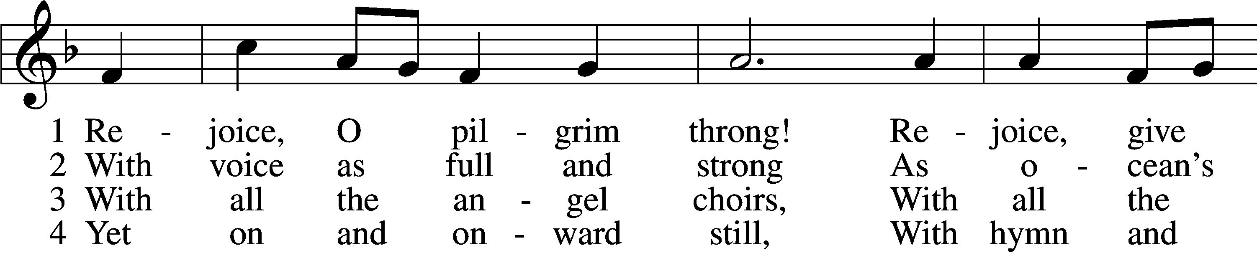
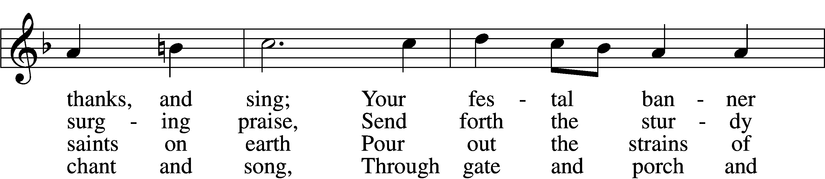
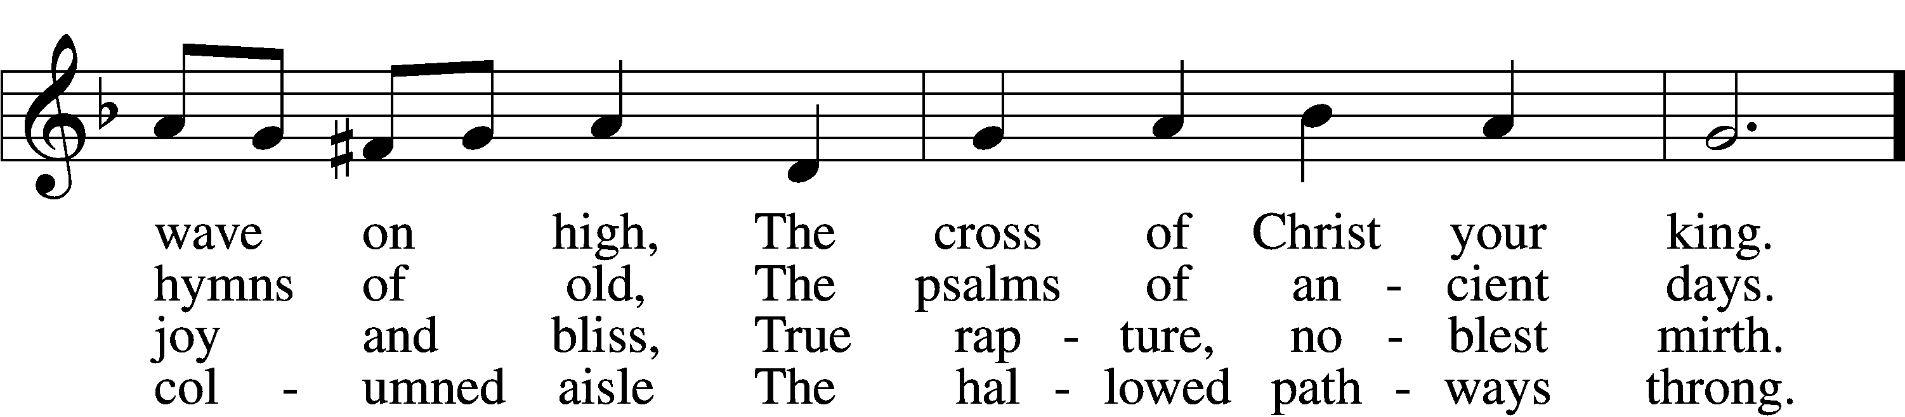
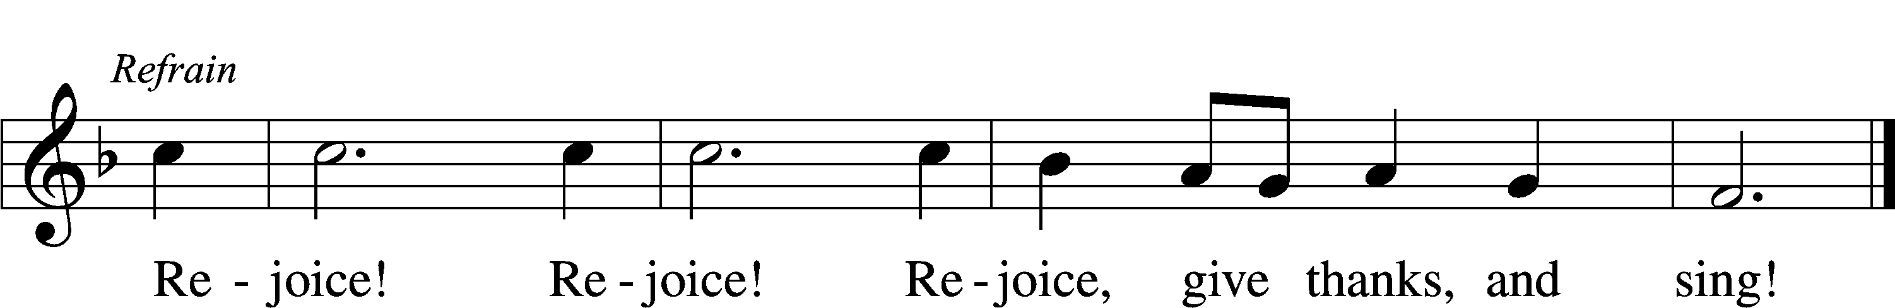
Text: Edward H. Plumptre, 1821–91, alt.
Tune: Arthur H. Messiter, 1834–1916
Text and tune: Public domain

INVOCATION
P In the name of the Father and of the T Son and of the Holy Spirit.
C Amen.

OPENING SENTENCES Psalm 124:8; 130:3–4
P Our help is in the name of the Lord,
C who made heaven and earth.

P If You, O Lord, should mark iniquities, O Lord, who could stand?
C But with You there is forgiveness, that You may be feared.

CONFESSION AND ABSOLUTION
P The Spirit of God calls forth sacrifices pleasing to God: brotherly love, hospitality to strangers, care for all in need, faithfulness in marriage and the family, fearless joy in the Lord, right faith, and right worship. Let us ask God to forgive our sinful neglect of faith’s power to have free course in our life.
C Almighty God, we confess to You that we have sinned in thought, word, and deed. We have not loved You with our entire being, and we have not loved our neighbors as ourselves. Alone we remain without hope, health, or help. Have mercy on us, forgive us our sins, and lead us to everlasting life. Amen.

P May the God of peace equip you with everything good that you may do His will. In the stead and by the command of my Lord Jesus Christ, I forgive you all your sins in the name of the Father and of the T Son and of the Holy Spirit.
C Amen.

KYRIE LSB 204
C Lord, have mercy;
Christ, have mercy;
Lord, have mercy.

GLORIA IN EXCELSIS LSB 204
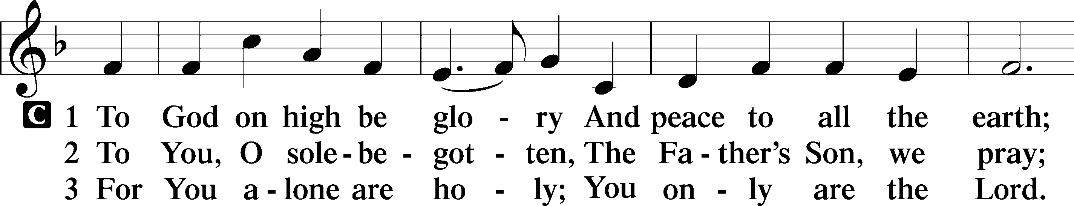
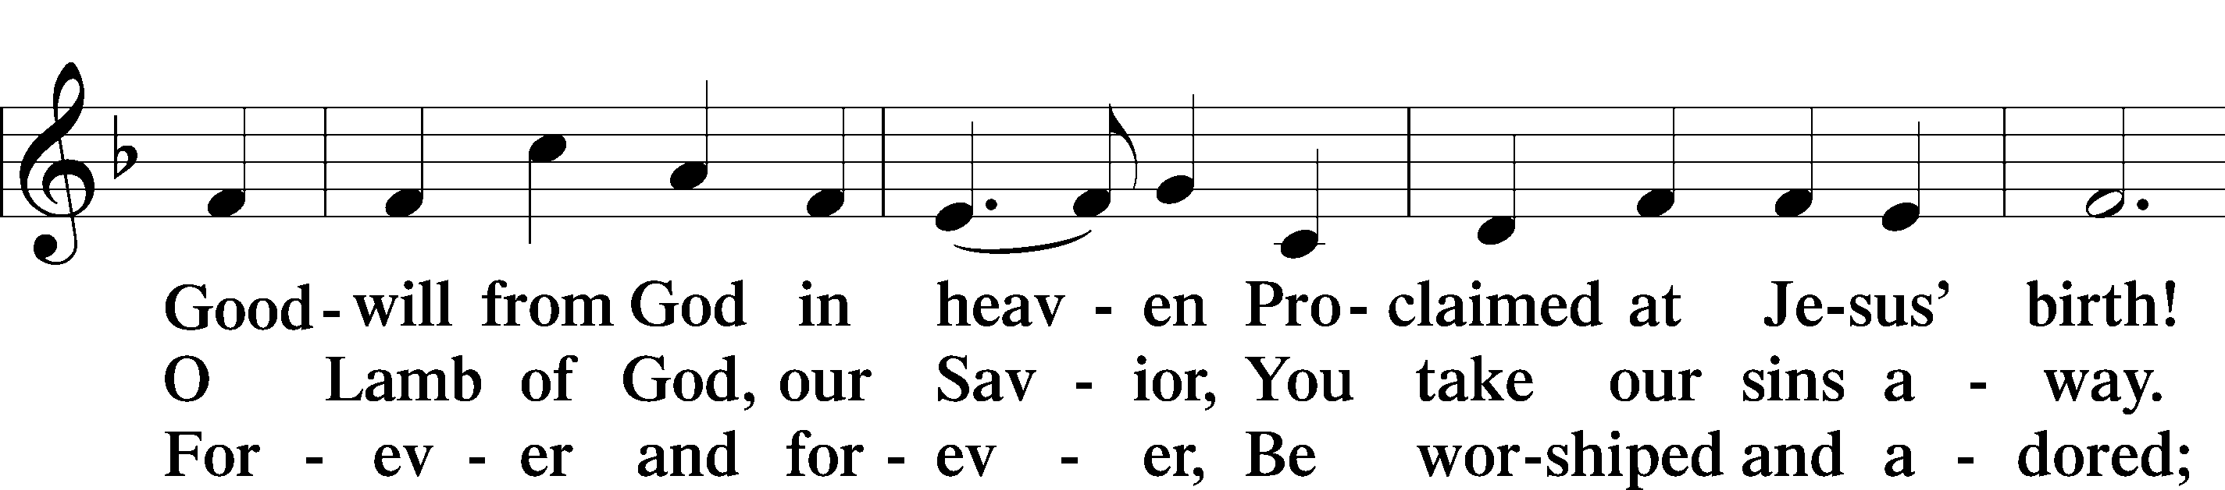
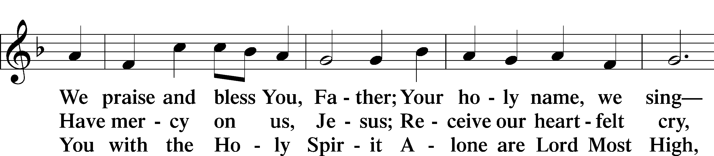
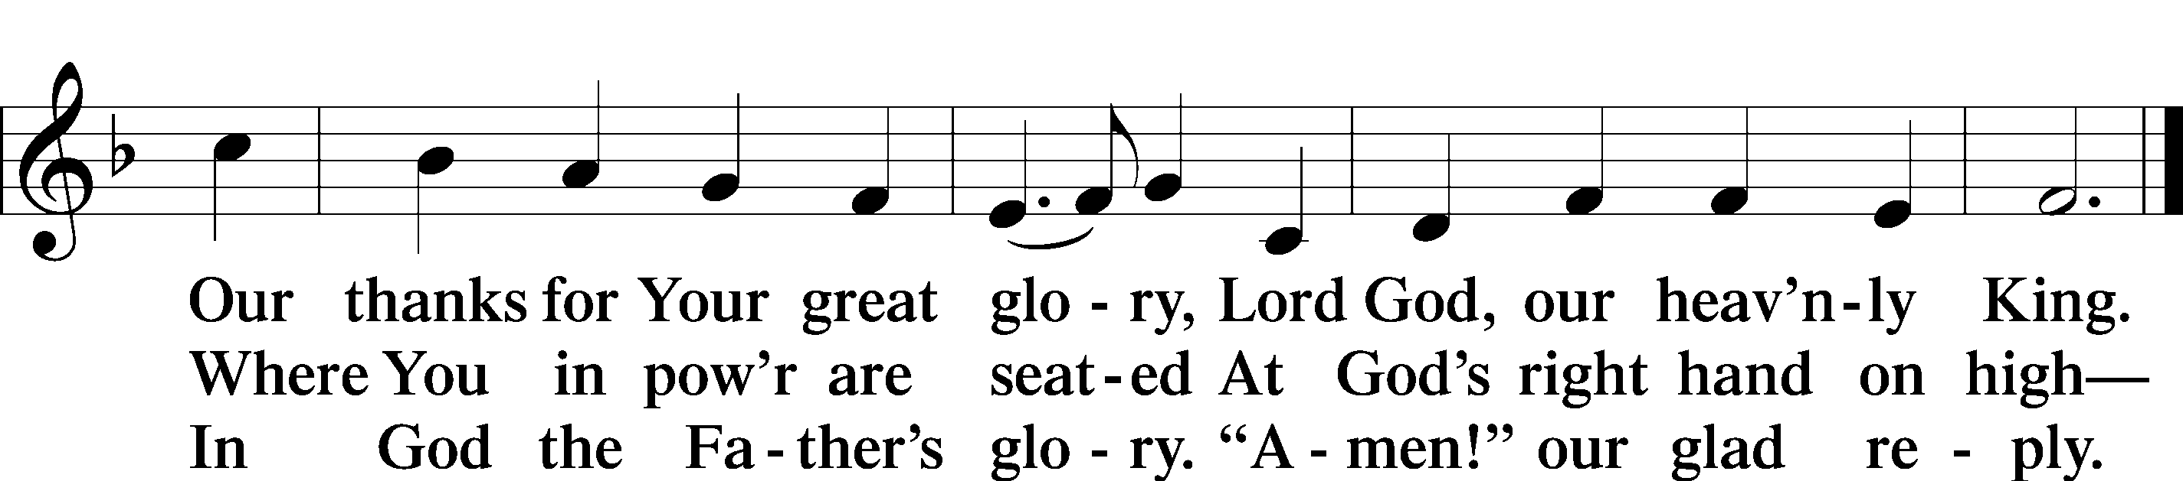
Text: Stephen P. Starke

SALUTATION
P The Lord be with you.
C And also with you.

PRAYER OF THE DAY
P Let us pray.
C O Lord of grace and mercy, teach us by Your Holy Spirit to follow the example of Your Son in true humility, that we may withstand the temptations of the devil and with pure hearts and minds avoid ungodly pride; through the same Jesus Christ, our Lord, who lives and reigns with You and the Holy Spirit, one God, now and forever.

OLD TESTAMENT READING Proverbs 25:2–10
2It is the glory of God to conceal things,
but the glory of kings is to search things out.
3As the heavens for height, and the earth for depth,
so the heart of kings is unsearchable.
4Take away the dross from the silver,
and the smith has material for a vessel;
5take away the wicked from the presence of the king,
and his throne will be established in righteousness.
6Do not put yourself forward in the king’s presence
or stand in the place of the great,
7for it is better to be told, “Come up here,”
than to be put lower in the presence of a noble.
What your eyes have seen
8do not hastily bring into court,
for what will you do in the end,
when your neighbor puts you to shame?
9Argue your case with your neighbor himself,
and do not reveal another’s secret,
10lest he who hears you bring shame upon you,
and your ill repute have no end.

L This is the Word of the Lord.
C Thanks be to God.

EPISTLE Hebrews 13:1–17
1Let brotherly love continue. 2Do not neglect to show hospitality to strangers, for thereby some have entertained angels unawares. 3Remember those who are in prison, as though in prison with them, and those who are mistreated, since you also are in the body. 4Let marriage be held in honor among all, and let the marriage bed be undefiled, for God will judge the sexually immoral and adulterous. 5Keep your life free from love of money, and be content with what you have, for he has said, “I will never leave you nor forsake you.” 6So we can confidently say,
“The Lord is my helper;
I will not fear;
what can man do to me?”
7Remember your leaders, those who spoke to you the word of God. Consider the outcome of their way of life, and imitate their faith. 8Jesus Christ is the same yesterday and today and forever. 9Do not be led away by diverse and strange teachings, for it is good for the heart to be strengthened by grace, not by foods, which have not benefited those devoted to them. 10We have an altar from which those who serve the tent have no right to eat. 11For the bodies of those animals whose blood is brought into the holy places by the high priest as a sacrifice for sin are burned outside the camp. 12So Jesus also suffered outside the gate in order to sanctify the people through his own blood. 13Therefore let us go to him outside the camp and bear the reproach he endured. 14For here we have no lasting city, but we seek the city that is to come. 15Through him then let us continually offer up a sacrifice of praise to God, that is, the fruit of lips that acknowledge his name. 16Do not neglect to do good and to share what you have, for such sacrifices are pleasing to God.
17Obey your leaders and submit to them, for they are keeping watch over your souls, as those who will have to give an account. Let them do this with joy and not with groaning, for that would be of no advantage to you.

L This is the Word of the Lord.
C Thanks be to God.

VERSE Luke 14:11
C Alleluia. Everyone who exalts himself will be humbled, and he who humbles himself will be exalted. Alleluia.

HOLY GOSPEL Luke 14:1–14
P The Holy Gospel according to St. Luke, the fourteenth chapter.
C Glory to You, O Lord.

1One Sabbath, when [Jesus] went to dine at the house of a ruler of the Pharisees, they were watching him carefully. 2And behold, there was a man before him who had dropsy. 3And Jesus responded to the lawyers and Pharisees, saying, “Is it lawful to heal on the Sabbath, or not?” 4But they remained silent. Then he took him and healed him and sent him away.
5And he said to them, “Which of you, having a son or an ox that has fallen into a well on a Sabbath day, will not immediately pull him out?” 6And they could not reply to these things.
7Now he told a parable to those who were invited, when he noticed how they chose the places of honor, saying to them, 8“When you are invited by someone to a wedding feast, do not sit down in a place of honor, lest someone more distinguished than you be invited by him, 9and he who invited you both will come and say to you, ‘Give your place to this person,’ and then you will begin with shame to take the lowest place. 10But when you are invited, go and sit in the lowest place, so that when your host comes he may say to you, ‘Friend, move up higher.’ Then you will be honored in the presence of all who sit at table with you. 11For everyone who exalts himself will be humbled, and he who humbles himself will be exalted.”
12He said also to the man who had invited him, “When you give a dinner or a banquet, do not invite your friends or your brothers or your relatives or rich neighbors, lest they also invite you in return and you be repaid. 13But when you give a feast, invite the poor, the crippled, the lame, the blind, 14and you will be blessed, because they cannot repay you. You will be repaid at the resurrection of the just.”

P This is the Gospel of the Lord.
C Praise to You, O Christ.

HYMN OF THE DAY “SON OF GOD, ETERNAL SAVIOR” #842
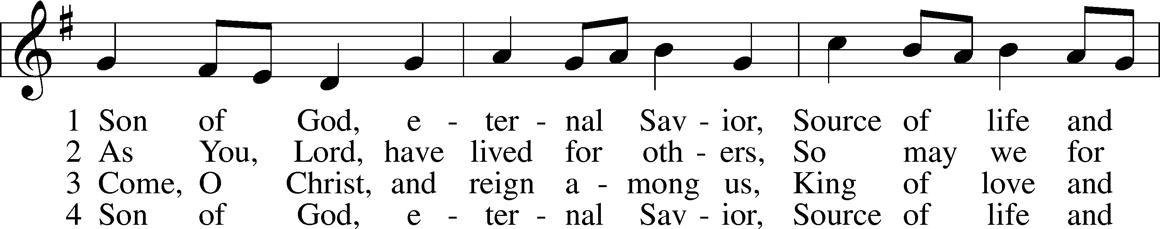
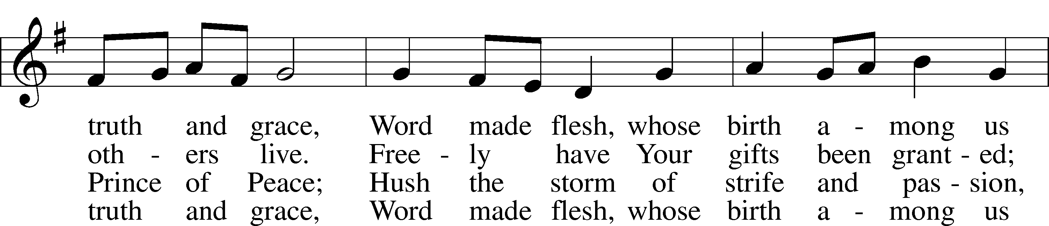
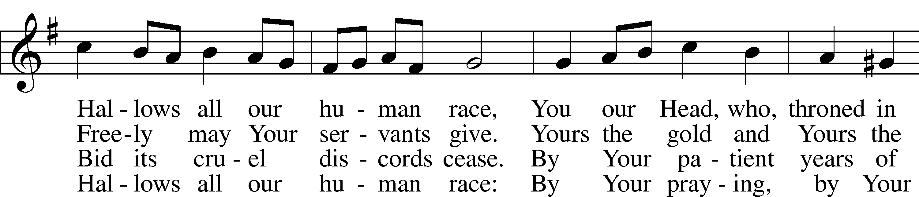
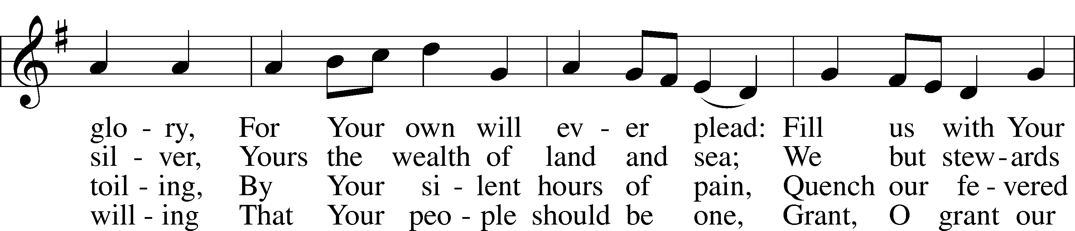
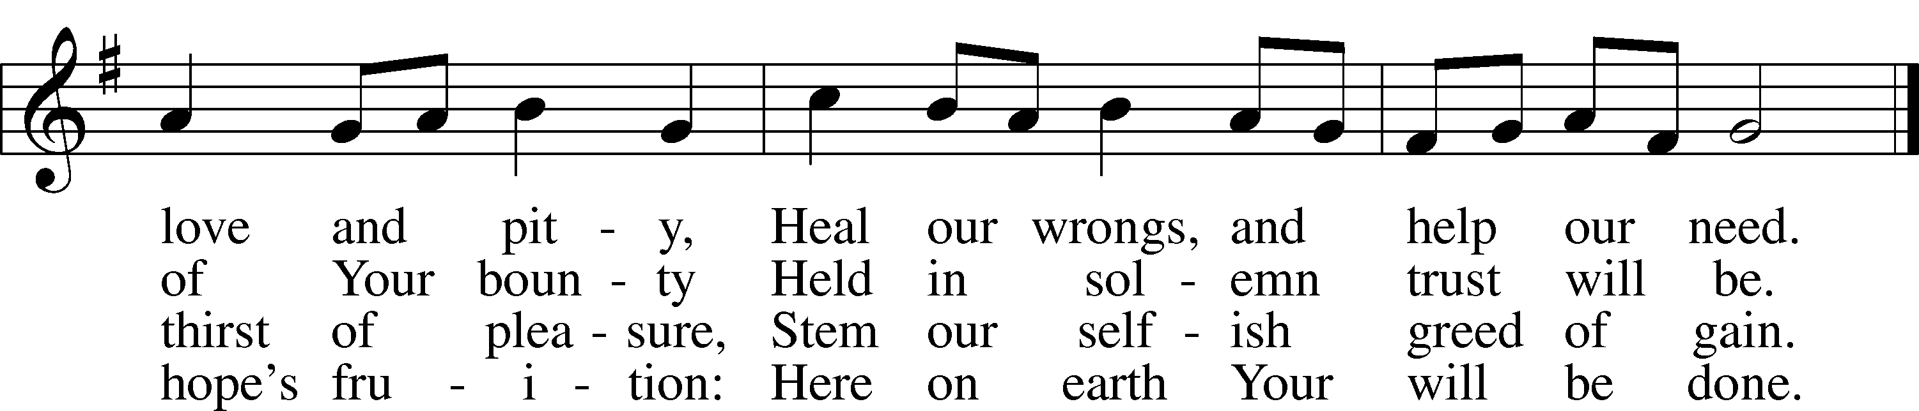
Text: Somerset T. C. Lowry, 1855–1932, alt.
Tune: Oude en Nieuwe Hollantse . . . Contradanseu, c. 1710, Amsterdam
Text and tune: Public domain

SERMON

APOSTLES’ CREED Nicene Creed
C I believe in God, the Father Almighty,
maker of heaven and earth.

And in Jesus Christ, His only Son, our Lord,
who was conceived by the Holy Spirit,
born of the virgin Mary,
suffered under Pontius Pilate,
was crucified, died and was buried.
He descended into hell.
The third day He rose again from the dead.
He ascended into heaven
and sits at the right hand of God the Father Almighty.
From thence He will come to judge the living and the dead.

I believe in the Holy Spirit,
the holy Christian Church,
the communion of saints,
the forgiveness of sins,
the resurrection of the body,
and the life T everlasting. Amen.

PRAYER OF THE CHURCH
P Almighty God, our heavenly Father, we give You thanks for all the goodness and loving kindness You have bestowed on us, especially for redeeming us through the great sacrifice of the death and resurrection of Your Son, our Lord Jesus Christ, and for giving us the gift of true repentance, faith, hope, and love by Your Holy Spirit. Work in us a right understanding of Your will, and grant us hearts, lips, and lives that show forth true thanksgiving in all we say and do. Lord, in Your mercy,
C hear our prayer.

P Have mercy upon all who are in authority over us, those who keep watch over our souls, as well as those in the authority of worldly government that we may have free course to live as Your redeemed people and serve one another in love. Bless all who serve to protect us in our nation and our community. Lord, in Your mercy,
C hear our prayer.

P Preserve those who travel and help all who call upon You in any need, that they may have patience and trust in the midst of suffering, we remember Hedy, Jean, Kathleen, Ray, Sally, Wally, Dana, Dennis, Kaylee, Kris, Jen, John, Jonathan, Leah, Rod and, according to Your will, be released from their afflictions. Lord, in Your mercy,
C hear our prayer.

P We remember with thanksgiving those who have loved and served You in Your Church on earth, who now rest from their labors, we especially remember Sharlene. Keep us in fellowship with all Your saints and bring us at last to the joys of Your heavenly kingdom. Lord, in Your mercy,
C hear our prayer.

P Into Your hands, O Lord, we commend all for whom we pray, trusting in Your mercy, through Your Son, Jesus Christ, our Lord.
C Amen.

LORD’S PRAYER
C Our Father who art in heaven,
hallowed be Thy name,
Thy kingdom come,
Thy will be done on earth
as it is in heaven;
give us this day our daily bread;
and forgive us our trespasses
as we forgive those
who trespass against us;
and lead us not into temptation,
but deliver us from evil.
For Thine is the kingdom
and the power and the glory
forever and ever. Amen.

BENEDICTION
P The Lord bless you and keep you.
The Lord make His face shine on you and be gracious to you.
The Lord look upon you with favor and T give you peace.
C Amen.

CLOSING HYMN “REJOICE, O PILGRIM THRONG” #813 sts. ref, 5–7
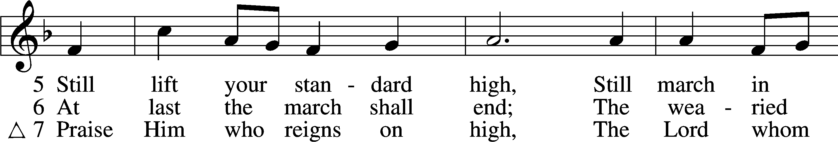
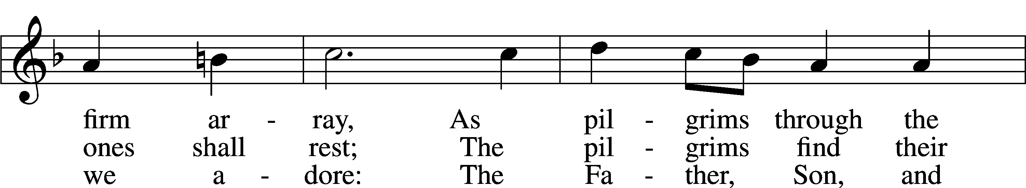
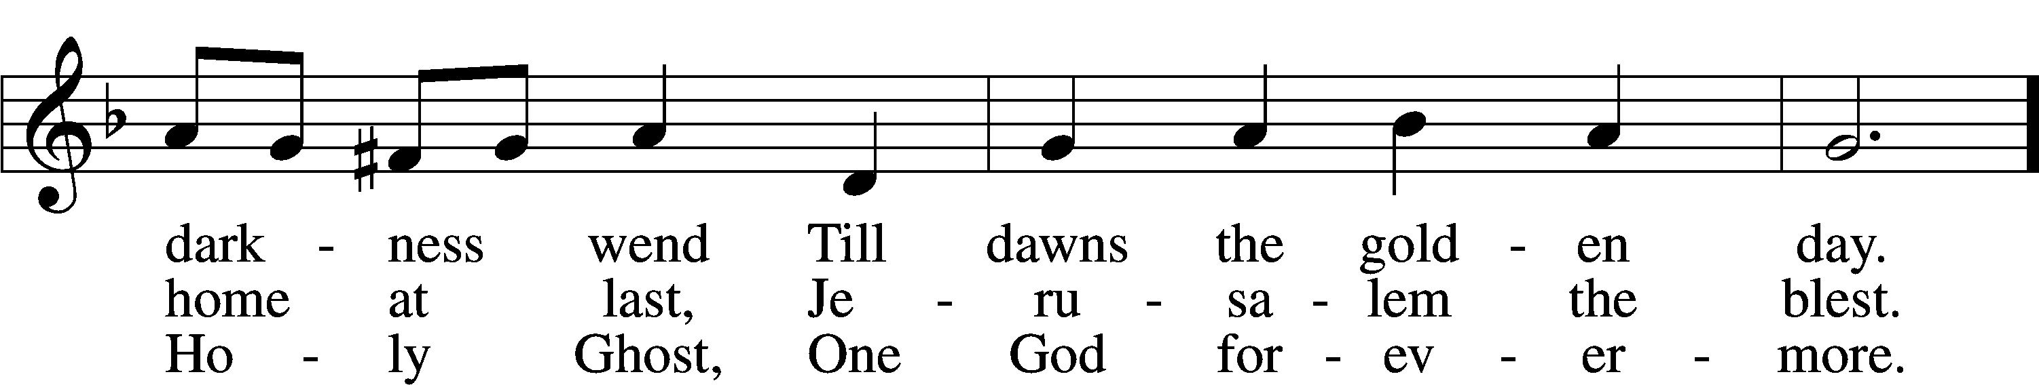
Text: Edward H. Plumptre, 1821–91, alt.
Tune: Arthur H. Messiter, 1834–1916
Text and tune: Public domain

ACKNOWLEDGMENTS—DO NOT REMOVE
Creative Worship for the Lutheran Parish, Series C, Quarter 3. Copyright © 2022 Concordia Publishing House.
All rights reserved. Used by permission.

ACKNOWLEDGMENTS
Unless otherwise indicated, Scripture quotations are from the ESV® Bible (The Holy Bible, English Standard Version®), copyright © 2001 by Crossway, a publishing ministry of Good News Publishers. Used by permission. All rights reserved.
Created by Lutheran Service Builder © 2022 Concordia Publishing House.
LSB Hymn License No. 110001439

