Our Redeemer Lutheran Church Prospect Heights, IL
Thirteenth Sunday after Pentecost September 4, 2022

CHOOSE LIFE!

AS WE GATHER
The first issue that naturally comes to mind to many Christians when hearing the phrase “Choose life!” is that of abortion, which chooses death, not life. And indeed, never should our witness to God’s gift of life be silenced! Beyond that, however, are all the other choices we make in our struggles between God’s good and gracious will for all and the universal disability of sin that constantly attempts to lead us away from God and His call to life. Today, God’s Word gives us the assurance that because our Lord and Savior Jesus Christ has chosen to take our suffering and death into Himself by His cross, all who are baptized into His saving death are given the power of faith to love God and pursue His ways of life according to His good and gracious Law and Gospel. Blessed is the man whose “delight is in the law of the Lord” (Psalm 1:2).

OPENING HYMN “WITH THE LORD BEGIN YOUR TASK” #869
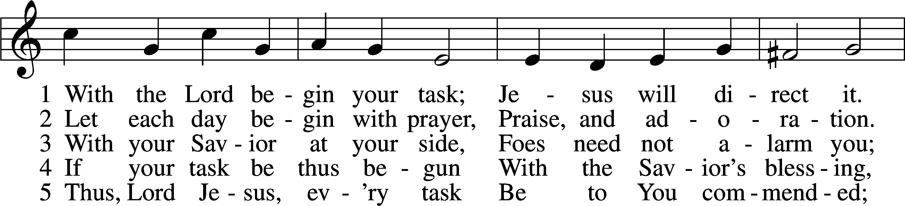
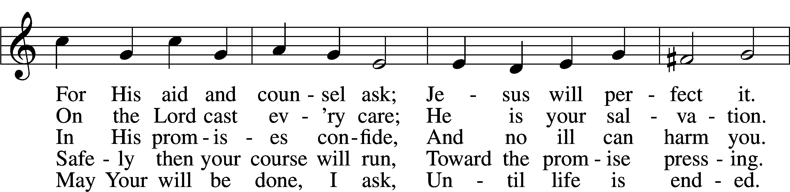
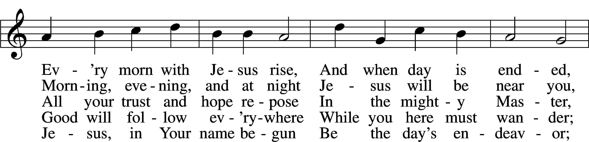
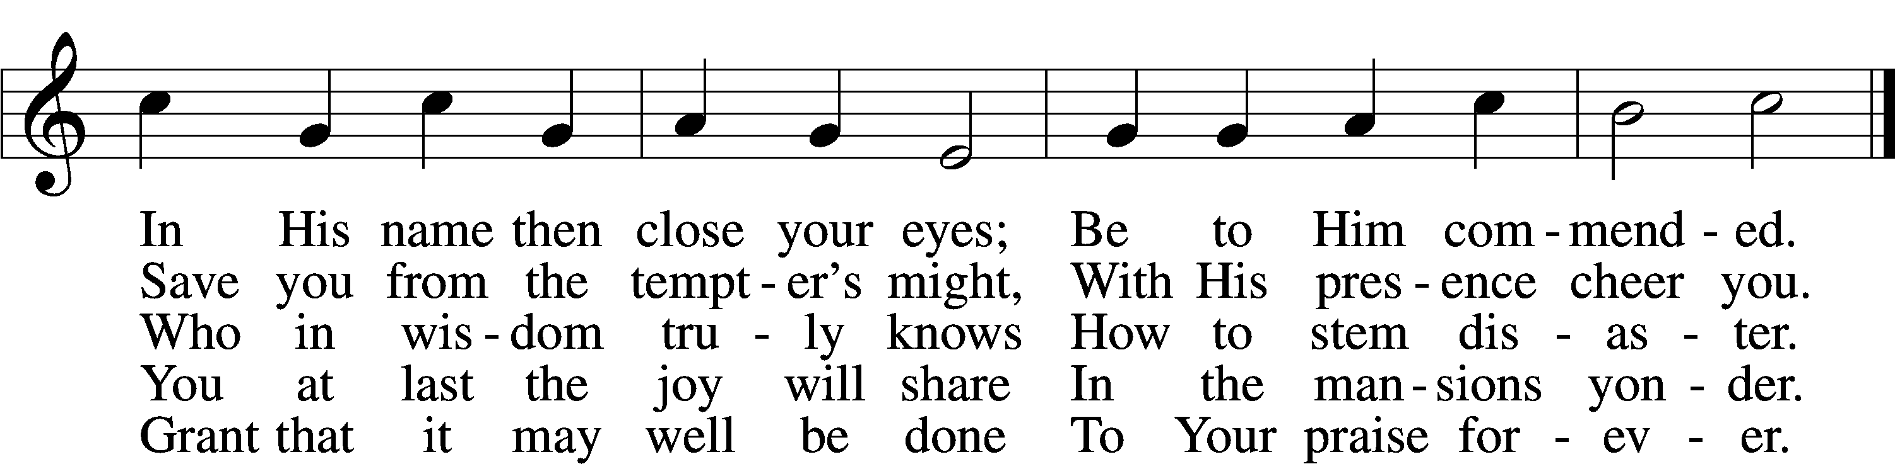
Text: Morgen- und Abend-segen, 1734, Waldenburg; tr. W. Gustave Polack, 1890–1950, alt.
Tune: Peter Frank, 1616–75
Text: © 1941 Concordia Publishing House. Used by permission: LSB Hymn License no. 110001439
Tune: Public domain

INVOCATION
P In the name of the Father and of the T Son and of the Holy Spirit.
C Amen.

OPENING SENTENCES Psalm 124:8; Isaiah 2:3, 5
P Our help is in the name of the Lord,
C who made heaven and earth.

P Come, let us walk in the light of the Lord,
C that He may teach us His ways and that we may walk in His paths.

CONFESSION AND ABSOLUTION Deuteronomy 30:14
P Since God graciously calls all people to come to Him to receive His love and life through repentance of sin and faith in His gift of forgiveness, let us confess our sin, take refuge in His mercy, and seek His grace for the sake of His Son, Jesus Christ, our Lord.
C Most merciful God, we come before You at Your gracious invitation. We repent of our sins in thought, word, and deed, both what we have done against Your Law and what we have failed to do in faithfulness to Your Law. We have not loved You with our whole being. We have failed to love our neighbors. We plead through the deliverance of Your Son’s suffering and death, forgive us our sins, and give us the will to choose life in His name. Amen.

P “The word is very near you. It is in your mouth and in your heart, so that you can do it.” In the stead and by the command of my Lord Jesus Christ, and by His authority, I forgive you all your sins in the name of the Father and of the T Son and of the Holy Spirit. You are free. Choose life!
C Amen.

SALUTATION
P The Lord be with you.
C And also with you.

PRAYER OF THE DAY
P Let us pray.
C O merciful Lord, You did not spare Your only Son but delivered Him up for us all. Grant us courage and strength to take up the cross and follow Him, who lives and reigns with You and the Holy Spirit, one God, now and forever.
C Amen.

PSALM READING Psalm 119:28–32; antiphon: v. 27
Make me understand the way of your precepts,
and I will meditate on your wondrous works.
My soul melts away for sorrow;
strengthen me according to your word!
Put false ways far from me
and graciously teach me your law!
I have chosen the way of faithfulness;
I set your just decrees before me.
I cling to your testimonies, O Lord;
let me not be put to shame!
I will run in the way of your commandments
when you enlarge my heart!
Make me understand the way of your precepts,
and I will meditate on your wondrous works.
L This is the Word of the Lord.
C Thanks be to God.

OLD TESTAMENT READING Deuteronomy 30:15–20
15“See, I have set before you today life and good, death and evil. 16If you obey the commandments of the Lord your God that I command you today, by loving the Lord your God, by walking in his ways, and by keeping his commandments and his statutes and his rules, then you shall live and multiply, and the Lord your God will bless you in the land that you are entering to take possession of it. 17But if your heart turns away, and you will not hear, but are drawn away to worship other gods and serve them, 18I declare to you today, that you shall surely perish. You shall not live long in the land that you are going over the Jordan to enter and possess. 19I call heaven and earth to witness against you today, that I have set before you life and death, blessing and curse. Therefore choose life, that you and your offspring may live, 20loving the Lord your God, obeying his voice and holding fast to him, for he is your life and length of days, that you may dwell in the land that the Lord swore to your fathers, to Abraham, to Isaac, and to Jacob, to give them.”

L This is the Word of the Lord.
C Thanks be to God.

VERSE Galatians 6:14
C Alleluia. Far be it from me to boast except in the cross of our Lord Jesus Christ, by which the world has been crucified to me, and I to the world. Alleluia.

HOLY GOSPEL Luke 14:25–35
P The Holy Gospel according to St. Luke, the fourteenth chapter.
C Glory to You, O Lord.

25Now great crowds accompanied [Jesus], and he turned and said to them, 26“If anyone comes to me and does not hate his own father and mother and wife and children and brothers and sisters, yes, and even his own life, he cannot be my disciple. 27Whoever does not bear his own cross and come after me cannot be my disciple. 28For which of you, desiring to build a tower, does not first sit down and count the cost, whether he has enough to complete it? 29Otherwise, when he has laid a foundation and is not able to finish, all who see it begin to mock him, 30saying, ‘This man began to build and was not able to finish.’ 31Or what king, going out to encounter another king in war, will not sit down first and deliberate whether he is able with ten thousand to meet him who comes against him with twenty thousand? 32And if not, while the other is yet a great way off, he sends a delegation and asks for terms of peace. 33So therefore, any one of you who does not renounce all that he has cannot be my disciple.
34“Salt is good, but if salt has lost its taste, how shall its saltiness be restored? 35It is of no use either for the soil or for the manure pile. It is thrown away. He who has ears to hear, let him hear.”

P This is the Gospel of the Lord.
C Praise to You, O Christ.

HYMN OF THE DAY “O GOD, MY FAITHFUL GOD” #696 sts. 1–4
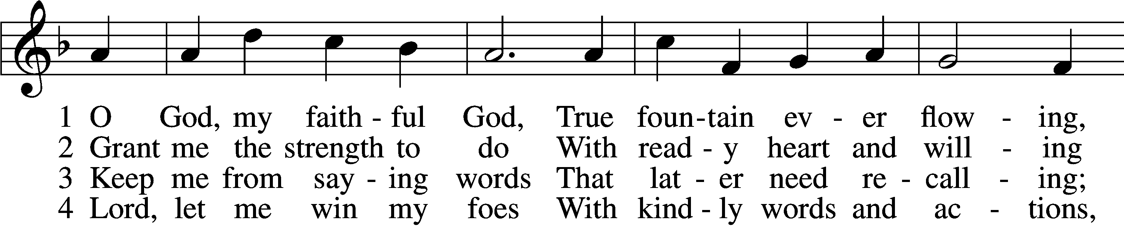
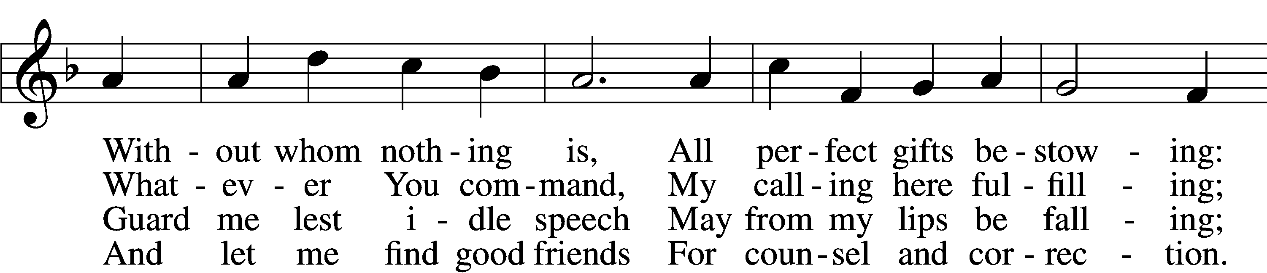
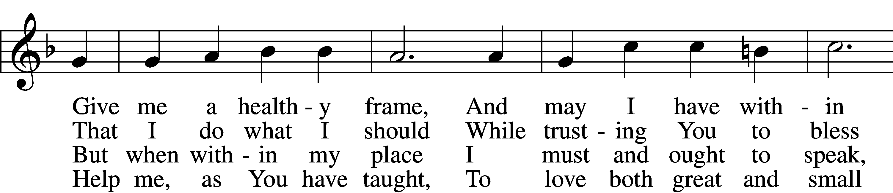
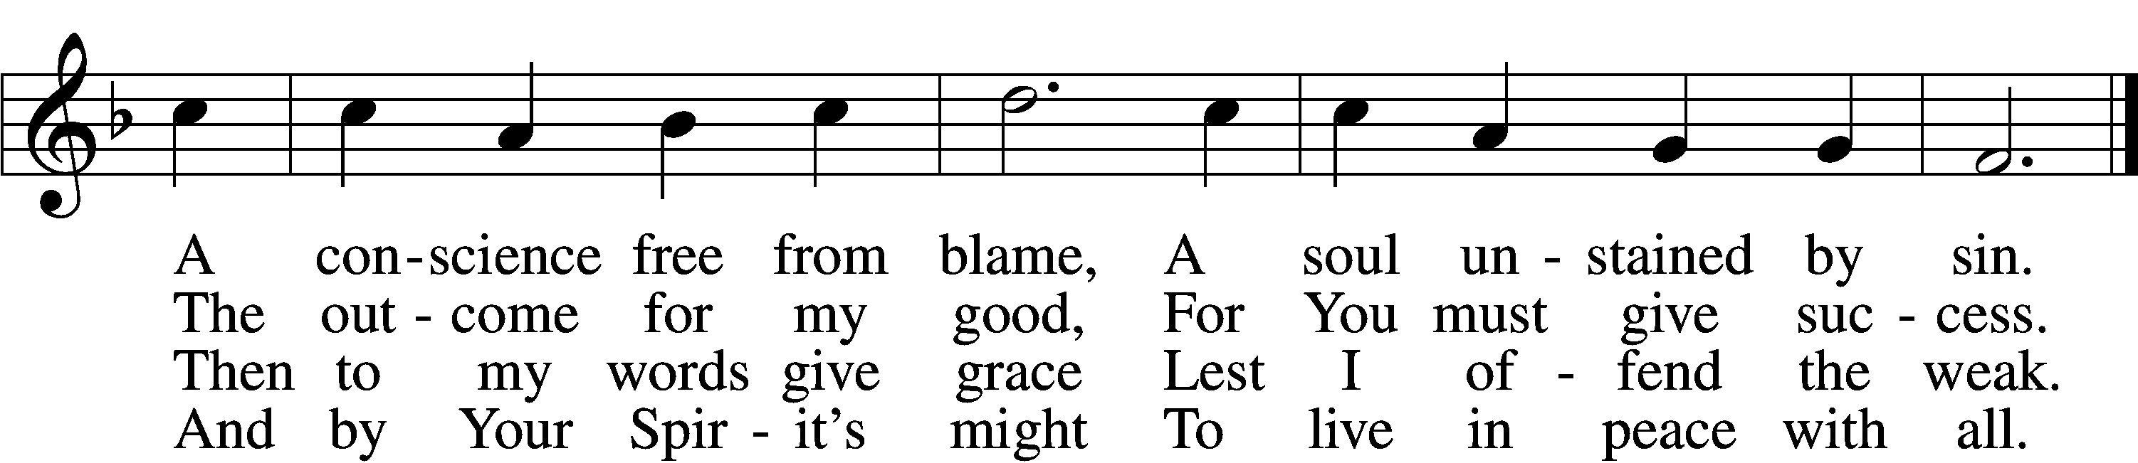
Text: Johann Heermann, 1585–1647; tr. Catherine Winkworth, 1827–78, alt.
Tune: Neu-vermehrtes . . . Gesangbuch, 1693, 3rd ed., Meiningen
Text and tune: Public domain

SERMON

CREED Nicene Creed
C I believe in one God,
the Father Almighty,
maker of heaven and earth
and of all things visible and invisible.

And in one Lord Jesus Christ,
the only-begotten Son of God,
begotten of His Father before all worlds,
God of God, Light of Light,
very God of very God,
begotten, not made,
being of one substance with the Father,
by whom all things were made;
who for us men and for our salvation came down from heaven
and was incarnate by the Holy Spirit of the virgin Mary
and was made man;
and was crucified also for us under Pontius Pilate.
He suffered and was buried.
And the third day He rose again according to the Scriptures
and ascended into heaven
and sits at the right hand of the Father.
And He will come again with glory to judge both the living and the dead,
whose kingdom will have no end.

And I believe in the Holy Spirit,
the Lord and giver of life,
who proceeds from the Father and the Son,
who with the Father and the Son together is worshiped and glorified,
who spoke by the prophets.
And I believe in one holy Christian and apostolic Church,
I acknowledge one Baptism for the remission of sins,
and I look for the resurrection of the dead
and the life T of the world to come. Amen.

PRAYER OF THE CHURCH
P All praise, honor, and worship be to You, O God our Father, for by Your Law You have revealed to the world Your salvation from all sin and death and given to all new hearts and renewed minds through the repentance of our sins and faith in Your Son, our Savior Jesus Christ. Help us to follow in His way to joyfully choose His life by means of His truth. Lord, in Your mercy,
C hear our prayer.

P Guide our nation and our elected leaders in the ways of justice, peace, and the promotion of lives pleasing to You. Preserve and bless all who serve in the armed forces of our nation as well as those who work to preserve peace, safety, and health in our community. Lord, in Your mercy,
C hear our prayer.

P Comfort and bring healing to all who are in sorrow, need, sickness, or adversity, especially Hedy, Jean, Kathleen, Ray, Sally, Wally, Dana, Dennis, Kaylee, Kris, Jen, John, Jonathan, Leah, Rod. Give strength and the will to persevere to all who suffer any persecution for the faith. Help all to whom death draws near with the peace of a confident faith. Lord, in Your mercy,
C hear our prayer.

P Into Your hands, O Lord, we commend all for whom we pray, trusting in Your mercy, through Your Son, Jesus Christ, our Lord.
C Amen.

HYMN OF PRAISE “PRAISE AND THANKSGIVING” #789
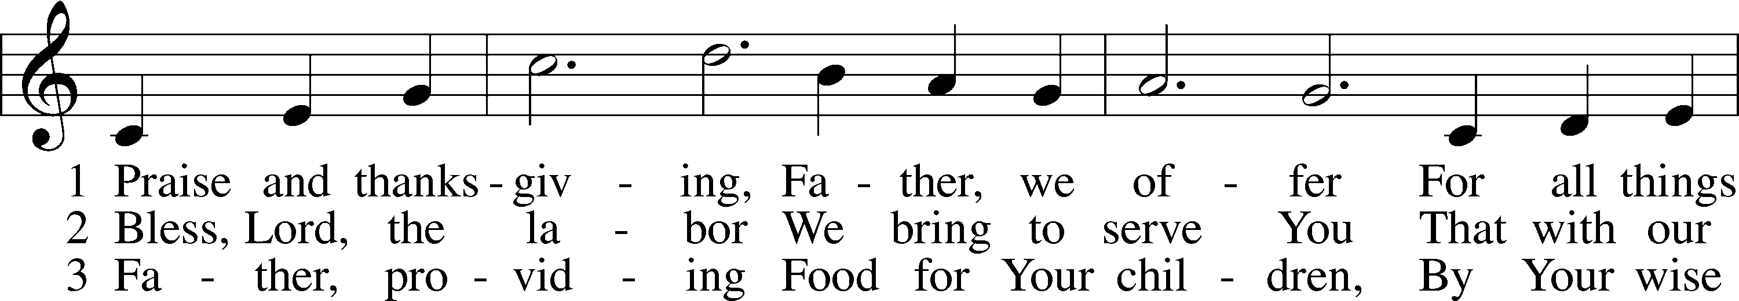
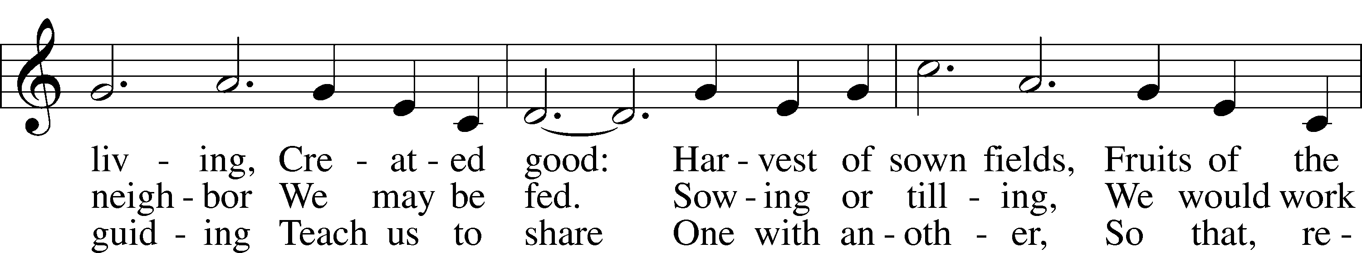
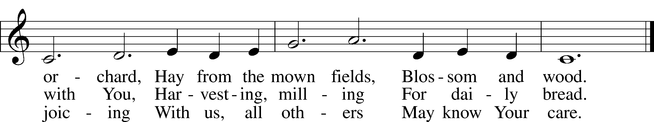
Text: Albert F. Bayly, 1901–84
Tune: Gaelic, 19th cent.
Text: © 1987 Oxford University Press. Used by permission: LSB Hymn License no. 110001439
Tune: Public domain

PREFACE
P The Lord be with you.
C And also with you.

P Lift up your hearts.
C We lift them to the Lord.

P Let us give thanks to the Lord our God.
C It is right to give Him thanks and praise.

PRAYER OF THANKSGIVING
P Let us pray.
C Blessed are You, O Lord our God, King of all creation, for You have had mercy on us and given Your only-begotten Son that whoever believes in Him should not perish but have eternal life. We give You thanks for the redemption You have prepared for us through Jesus Christ. Grant us Your Holy Spirit that we may faithfully eat and drink of the fruits of His cross and receive the blessings of forgiveness, life, and salvation that come to us in His body and blood. Hear us as we pray in His name and as He has taught us:

LORD’S PRAYER
C Our Father who art in heaven,
hallowed be Thy name,
Thy kingdom come,
Thy will be done on earth
as it is in heaven;
give us this day our daily bread;
and forgive us our trespasses
as we forgive those
who trespass against us;
and lead us not into temptation,
but deliver us from evil.
For Thine is the kingdom
and the power and the glory
forever and ever. Amen.

THE WORDS OF OUR LORD
P Our Lord Jesus Christ, on the night when He was betrayed, took bread, and when He had given thanks, He broke it and gave it to the disciples and said: “Take, eat; this is My T body, which is given for you. This do in remembrance of Me.”

In the same way also He took the cup after supper, and when He had given thanks, He gave it to them, saying: “Drink of it, all of you; this cup is the new testament in My T blood, which is shed for you for the forgiveness of sins. This do, as often as you drink it, in remembrance of Me.”

PAX DOMINI
P The peace of the Lord be with you always.
C Amen.

AGNUS DEI LSB 210
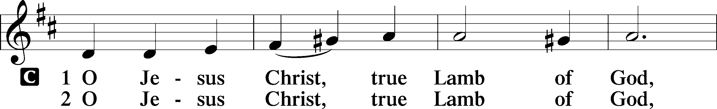
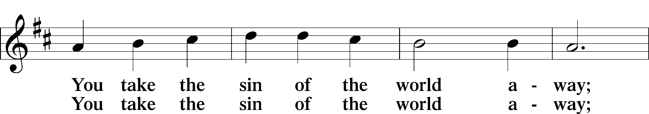
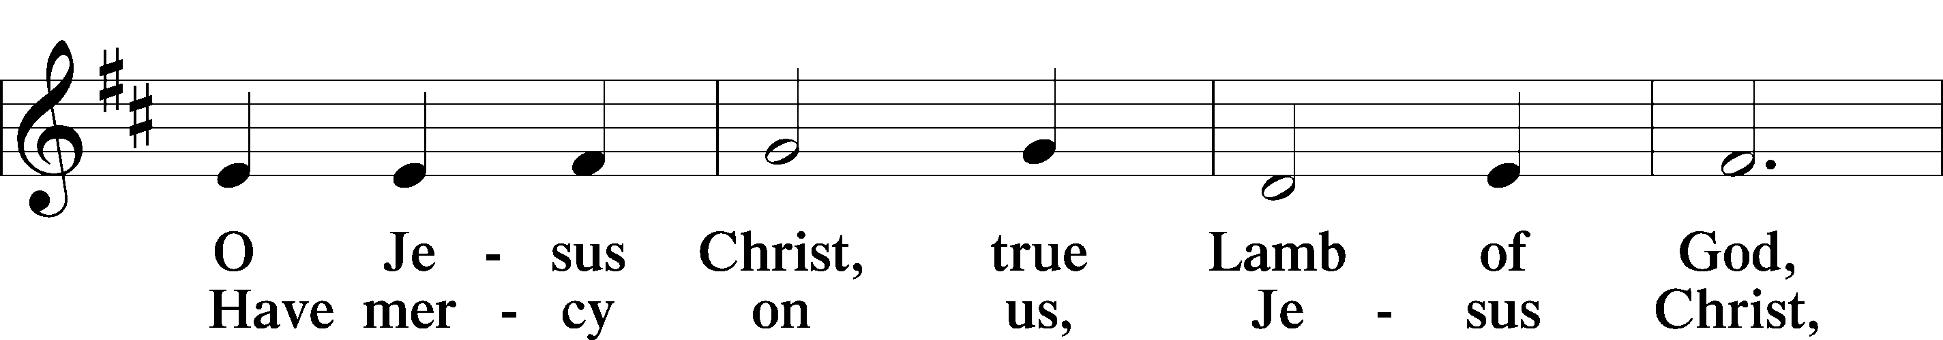
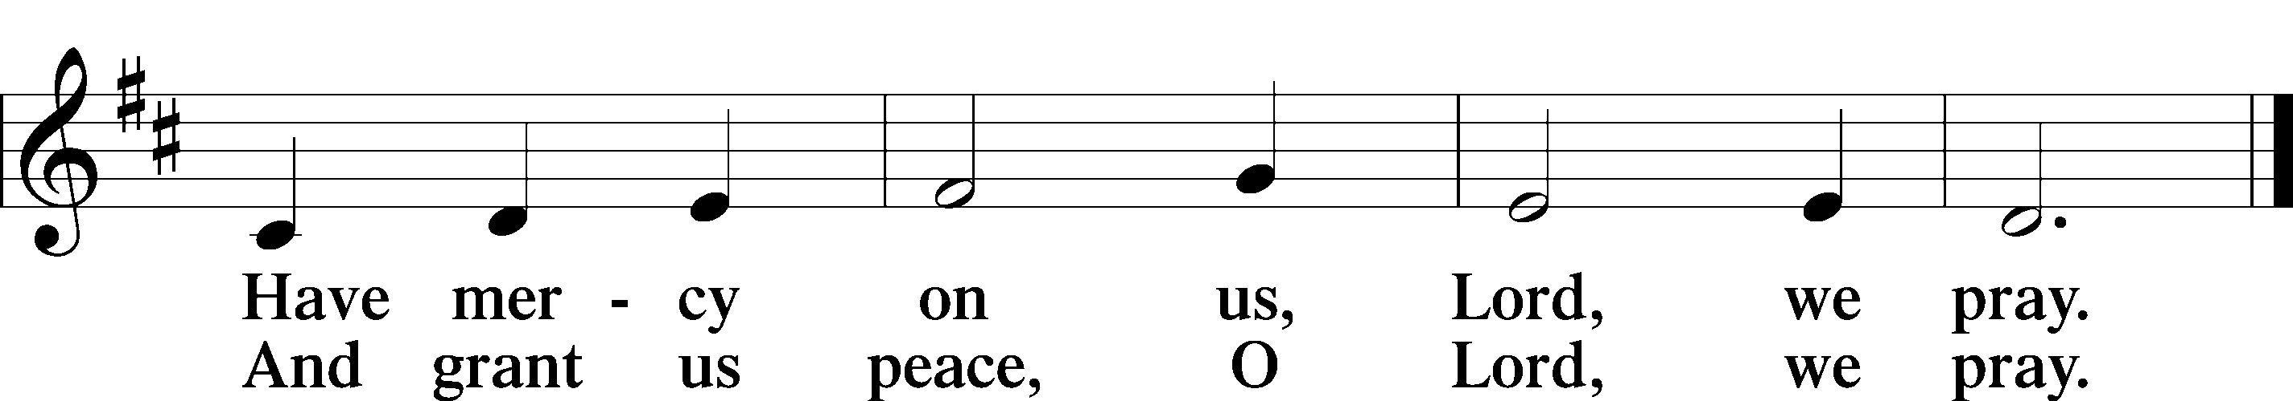
Text: Stephen P. Starke

DISTRIBUTION HYMN
“LORD, ’TIS NOT THAT I DID CHOOSE THEE” #573
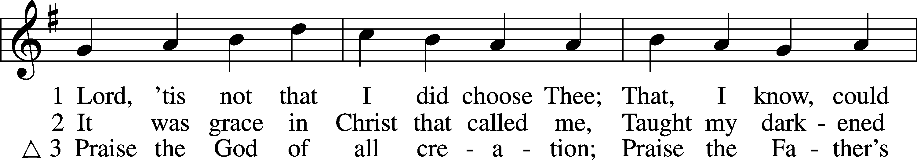
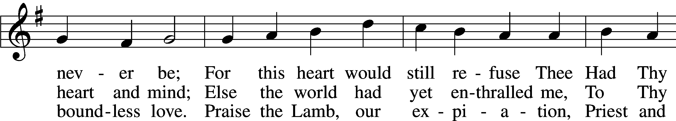
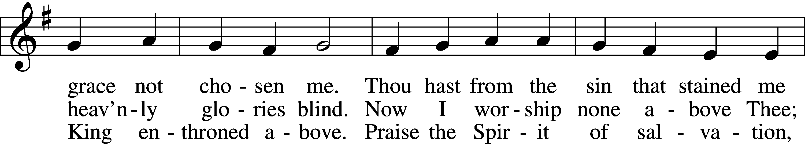
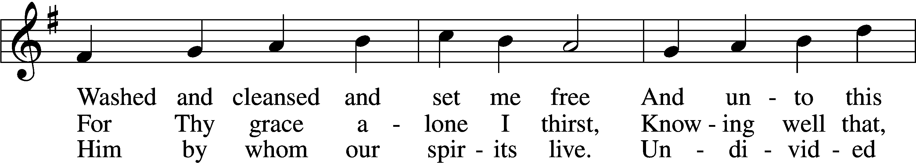
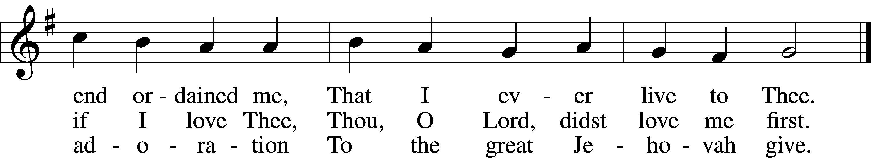
Text: Josiah Conder, 1789–1855, alt.
Tune: Erbaulicher Musicalischer Christen-Schatz, 1745, Basel
Text and tune: Public domain

POST-COMMUNION THANKSGIVING
P Let us pray together.
C O God the Father, the fountain and source of all goodness, who in loving-kindness sent Your only-begotten Son into the flesh, we thank You that for His sake You have given us pardon and peace in this Sacrament, and we ask You not to forsake Your children but always to rule our hearts and minds by Your Holy Spirit that we may be enabled constantly to serve You; through Jesus Christ, Your Son, our Lord, who lives and reigns with You and the Holy Spirit, one God, now and forever.
C Amen.

BENEDICTION
P The Lord bless you and keep you.
The Lord make His face shine on you and be gracious to you.
The Lord look upon you with favor and T give you peace.
C Amen.

CLOSING HYMN “ALL PEOPLE THAT ON EARTH DO DWELL” #791
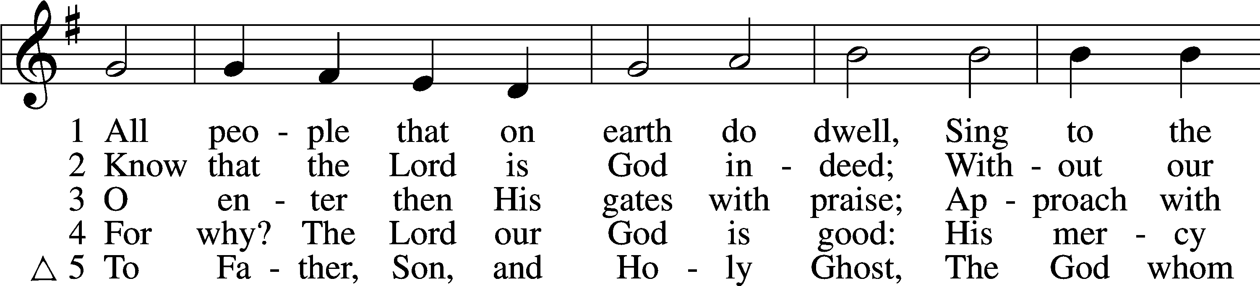
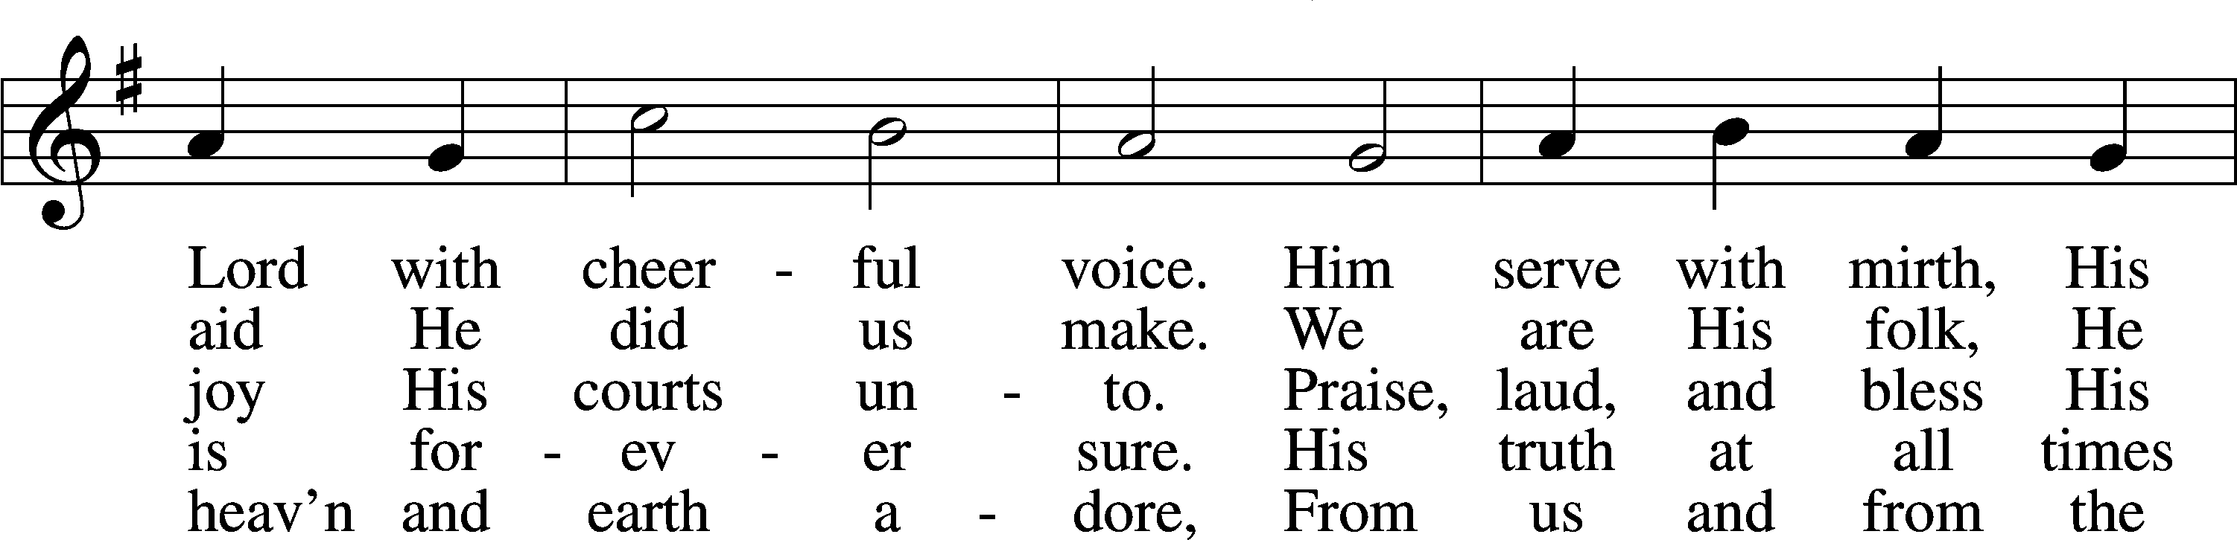
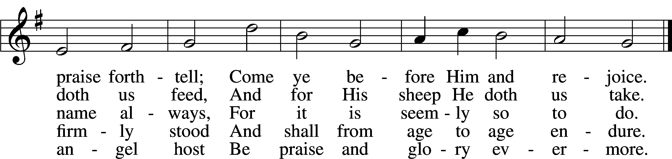
Text: William Kethe, d. c. 1593, alt.
Tune: Trente quatre Pseaumes de David, 1551, Geneva, ed. Louis Bourgeois
Text and tune: Public domain

ACKNOWLEDGMENTS—DO NOT REMOVE
Creative Worship for the Lutheran Parish, Series C, Quarter 3. Copyright © 2022 Concordia Publishing House.
All rights reserved. Used by permission.

ACKNOWLEDGMENTS
Unless otherwise indicated, Scripture quotations are from the ESV® Bible (The Holy Bible, English Standard Version®), copyright © 2001 by Crossway, a publishing ministry of Good News Publishers. Used by permission. All rights reserved.
Created by Lutheran Service Builder © 2022 Concordia Publishing House.
LSB Hymn License No. 110001439

